Appendix B – Manufacturer’s CLS Product Information
This form is available in a Microsoft Word version from the ENA’s website.
G100/2 - Form B - Compliance Verification Report for Customer Export or Import Limitation Schemes
This form shall be used by the Manufacturer to demonstrate and declare compliance with the requirements of EREC G100. The form can be used in a variety of ways as detailed below:
1. For Fully Type Tested status
The Manufacturer can use this form to obtain Fully Type Tested status for a CLS by registering this completed form with the Energy Networks Association (ENA) Type Test Register.
2. To obtain Type Tested status for a product
The Manufacturer can use this form to obtain Type Tested status for one or more Components which are used in a CLS by registering this form with the relevant parts completed with the Energy Networks Association (ENA) Type Test Register.
3. One-off Installation
The Installer can use this form to confirm that the CLS has been tested to satisfy the requirements of this EREC G100. This form shall be submitted to the DNO before commissioning.
A combination of (2) and (3) can be used as required, together with Form C where compliance of the CLS is to be demonstrated on site.
Note:
If the CLS is Fully Type Tested and registered with the Energy Networks Association (ENA) Type Test Register, Form C shall include the Manufacturer’s reference number (the Type Test Register system reference), and this form does not need to be submitted.
Where the CLS is not registered with the ENA Type Test Register or is not Fully Type Tested this form (all or in parts as applicable) shall be completed and provided to the DNO, to confirm that the CLS has been tested to satisfy all or part of the requirements of this EREC G100.
CLS Designation
Manufacturer name |  | SolarEdge Technologies Ltd.
Address |  | 1 HaMada Street, Herzeliya 4673335, Israel
Tel | +972-9-9576620 | Web site | https://www.solaredge.com/en
Email | Jason.Kirrage@solaredge.com
Installer’s name
Address
Tel |  | Web site
Email

Export/Import capabilities
Export | Y / N | Import | Y / N
Description of Operation
EREC G100 section 4.2 requires a description of the CLS, and schematic diagram, to be provided to the Customer. Please provide that description and the diagram here.
The SolarEdge end to end smart energy management solution is based on a centralised concept (Leader Follower) where the G100-2 CLS logic is implemented on the leader INV. The Leader INV is responsible for communication with both generation and SolarEdge smart load devices and as well the meter at the connection point.
SolarEdge CLS Controls & Settings
SolarEdge systems meet EREC G100 version 2 policy requirements through the following high-level control & settings:
- SolarEdge Energy Meter (monitoring PoC with the grid): The SolarEdge meter will ensure that the current is monitored in real-time at the main PoC, ensuring that all potential import / export current flows are captured by the SolarEdge CLS. For multiple incomers, these values are aggregated according to DNO requirements to ensure the requisite import / export limits are managed correctly.
- SolarEdge Control Response Times: The SolarEdge CLS response time are compliant to the G100 2nd amendment time harmonization requirement fixes and will tether the applicable import / export elements to ensure no excursion into State 2 is greater than 15 seconds.
- SolarEdge State 1, 2 & 3: SolarEdge’s solution meets the requirements (timing and allowable number of excursions) for state 1, 2 and 3 requirements, as detailed in the G100 2nd amendment policy.
- SolarEdge Interrogation & Data: SolarEdge’s solution captures all control, power and current data which is presented in real-time via an HMI (Human Machine Interface) both on site and off site which enables multi-tier extensive data interrogation (by either installer or manufacturer).

Customer connection scheme

Single Inverter
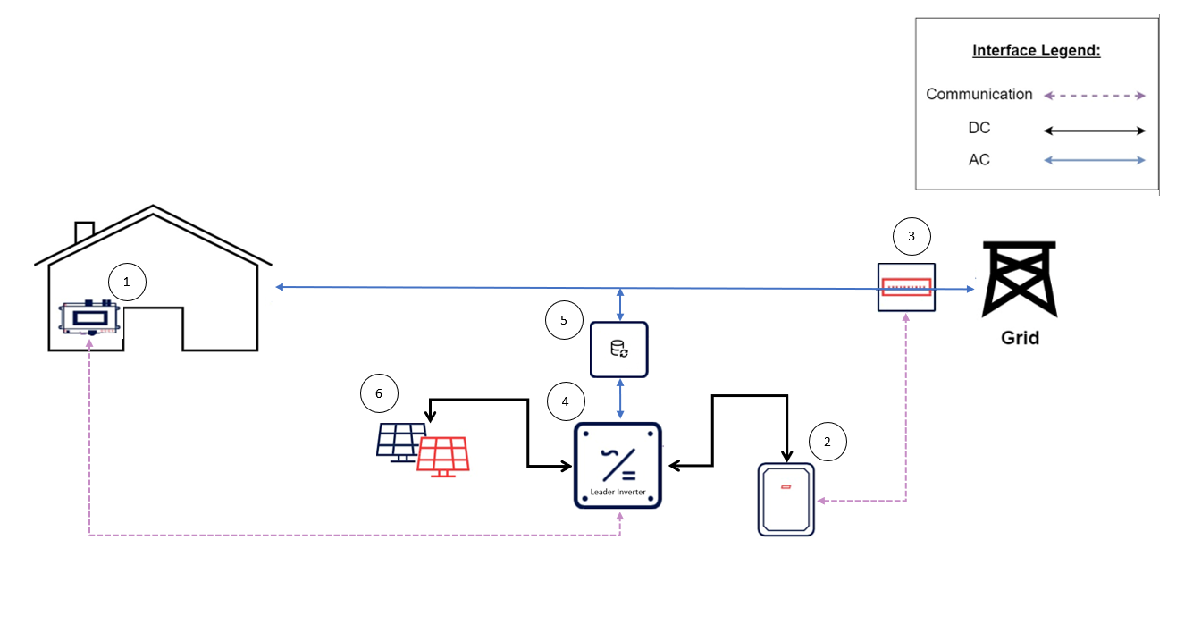

Multi Inverter
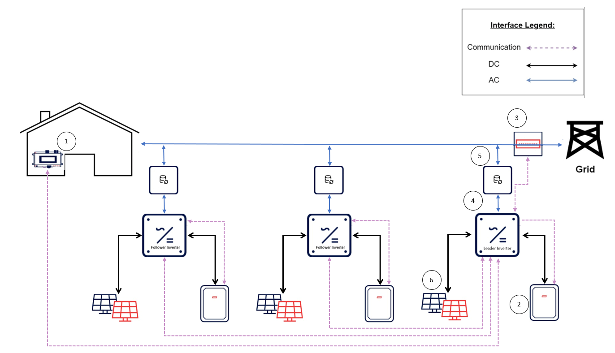

No. | Product type | Icon | Product number
1 | Smart devices | 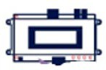 | SMRT-HOT-WTR-30-S1  SMRT-HOT-WTR-50-S1  DCS  Plug-in/socket  Switch  SE-EVK22URM-01
2 | Battery | 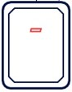
3 | Meter | 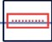 | SE-WND-3Y400-MB-K2  SE-MTR-3Y-400V-A
4 | Inverter | 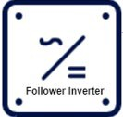 | SE20K  SE25K  SE27.6K  SE30K  SE33.3K SE50K  SE66.6K  SE90K  SE100K
5 | Backup Interface | 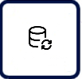
6 | PV | 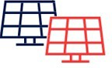 | -

Communications Media
Document the provisions made for the use of various communication media, and both the inherent characteristics and the design steps made to ensure security and reliability.
The communication mediums of the CLS can be Wired or Wireless and are registered by the CLS. At the commissioning process the device is registered as a generation/non generation device. The G100-2 logics are also implemented in each of the CLS devices.
- SolarEdge’s solution CLS Internal Communications: All the component parts within the Solution:
CLS system use a combination of:
  - Hard-wired serial Modbus RTU
  - Hard-wired wired communication (LAN)
  - Hard-wired serial dedicated protocol (over RS485)
  - Dedicated wireless communication (Sub-Giga)
  - Standardized wireless communication (Wi-Fi/LTE/Bluetooth)
- SolarEdge’s solution ‘Local Network’ Communications: All units that constitute the full SolarEdge’s solution CLS system are inter-connected by ‘hard-wired’ and dedicated communications cables. No 3rd party equipment is connected to this network, ensuring that we create a ring-fenced solution.
- Remote communications: SolarEdge’s solution CLS systems can either communicate remotely via homeowner local LAN or via LTE mobile router installed within the Inverters.

Cyber Security
Confirm that the Manufacturer or Installer of the CLS has provided a statement describing how the CLS has been designed to comply with cyber security requirements, as detailed in section.
We SolarEdge Technologies Ltd declare that G100 certified products,
And the variant models to be included in the certification,
Are in compliance with Cyber security requirements in accordance with the standards:

- ENA Engineering Recommendation G99 Issue 1 Amendment 8 2021
- ETSI EN 303 645;
- PAS 1879 “Energy smart appliances – Demand side response operation – Code of practice”;
Please also refer to the documents provided (SolarEdge declaration G99 Cyber and Information Security Management - Partner Information Pack).
Power Quality Requirements
Where the CLS includes the power electronics that controls generation or loads (as opposed to the power electronics being included in Devices that are subject to their own power quality compliance requirements) please submit the harmonic and disturbance information here as required by EREC G5 and EREC P28.
Not applicable to our system as it is not a stand-alone device, and it works as a system.

Fail Safe
CLS internal failure: please submit here the description of the internal Fail-Safe design and operation. Please also document how it has been demonstrated, including the non-volatile recording of times and numbers of state 2 operations, and confirm the overall response of the CLS to this internal failure.
Fail safe design and operation
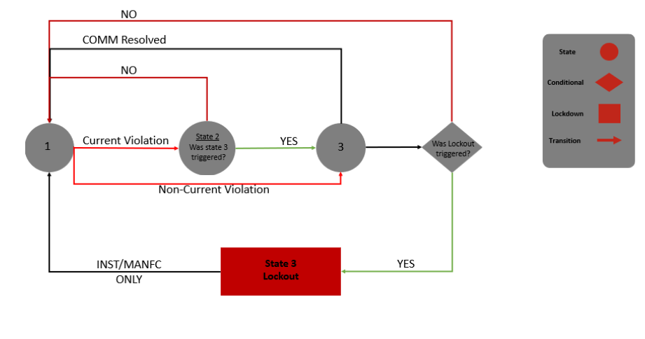
SolarEdge G100 Fail Safe Compliance
SolarEdge G100 CLS was designed with a fail-safe mechanism according to G100 section 4.5. Therefore, the SolarEdge system design ensures that it will limit the imported/exported current at the site to the DNO’s agreed limit(s).
All the components in the SolarEdge system are either wired or wireless and are registered by the CLS. At the commissioning process the device is registered as a generation/non generation device.
In the event of a detected failure the system will operate the Fail-safe mechanism by reducing the component generation to zero immediately according to the table above.

State 2 documentation
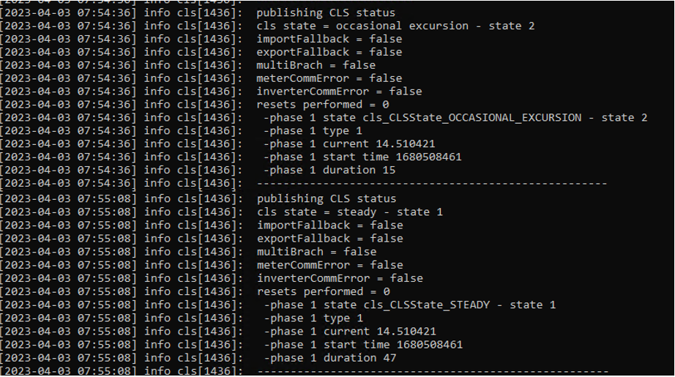

Communication and power supply failures between Components and Devices. Please document here compliance with EREC G100 section 5.5.
Component/Device number/description | Communication failure test | Power supply failure test
Meter  SE-WND-3Y400-MB-K2  SE-MTR-3Y-400V-A | PASS | PASS
Inverter  SE20K, SE25K, SE27.6K, SE30K, SE33.3K SE50K, SE66.6K, SE90K, SE100K | PASS | PASS
Heater Controller  SMRT-HOT-WTR-30-S1  SMRT-HOT-WTR-50-S1 | PASS | PASS
Smart load controller  DCS | PASS | PASS

Operational Tests
In accordance with EREC G100 section 5.6 undertake the tests A to D to confirm correct operation in state 1 and state 2, that transition into state 3 occurs as required, and that behaviour in state 3 is also as required.
Test A
Nominal Export Limit (for type tests this will be at maximum, minimum and one intermediate setting) in Amp: |  |  |  |  |  |  | 38A
Nominal Import Limit (for type tests this will be at maximum, minimum and one intermediate setting) in Amp: |  |  |  |  |  |  | 38A
No | Starting level | Step value | CLS registers change in level? | CLS and/or Component and/or Device initiates correct response of ≥ 5%? | Duration of step in test | Correct state 1/  state 2 operation
1 | 30 IAC | 31.5 IAC | Yes | Yes | 58s | 1 > 2 > 1
2 | 30 IAC | 33 IAC | Yes | Yes | 58s | 1 > 2 > 1
3 | 30 IAC | 36 IAC | Yes | Yes | 58s | 1 > 2 > 1
4 | 30 IAC | 31.5 IAC | Yes | Yes | 58s | 1 > 2 > 1
5 | 30 IAC | 33 IAC | Yes | Yes | 58s | 1 > 2 > 1
6 | 30 IAC | 36 IAC | Yes | Yes | 58s | 1 > 2 > 1
Test B
Nominal Export Limit: |  |  |  |  |  |  | 38A
Nominal Import Limit |  |  |  |  |  |  | 38A
No | Starting level | Step value | CLS registers change in level? | CLS and/or Component and/or Device initiates correct response of ≥ 5%? | Duration of step in test | Correct state 3 operation
7 | 30 IAC | 31.5 IAC | Yes | Yes | 62s | 1>2>3
8 | 30 IAC | 31.5 IAC | Yes | Yes | 62s | 1>2>3

State 3 Reset
These tests are to demonstrate compliance with section EREC G100 4.5.2.
Please document how the reset from state 3 to state 1 has been demonstrated. Please include how the reset is achieved.
Please confirm that for CLSs to be installed in Domestic installations three (3) resets causes lockout or that for non-domestic installations lockout can only be reset after four hours. Please explain how lockout is reset.
- System state is "State 3 - Lock-Out”.
- Expert investigation has ended successfully.
- CLS changes system state to "State 1 - Normal Operation" and sends commands to Load & Generation devices.
- CLS Clears all G.100 related events from its memory due to investigations.
- Devices receive the command and enter their Normal Operational Mode.
- CLS logs the state change.
- CLS sends generated event to "Cloud”.
- CLS sends and alert to a User Interface that the system is in "State 1 - Normal Operation”.

